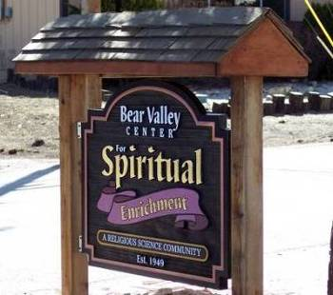
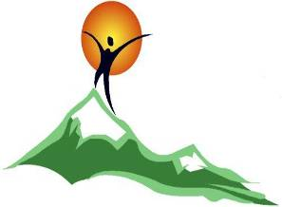

Bear Valley Center for Spiritual Enrichment

A Religious Science Community
“Open at the Top”
MAY 2022
Newsletter

Mailing address - P. O. Box 4184, Big Bear Lake, CA 92315,

Email:bvcse2000@gmail.com Website: www.bvcse.org

501C3 tax ID #95-3685187
Our purpose is to inspire and nurture spiritual growth by accepting a loving, all-inclusive community through teaching, healing, and serving, for the highest good of all.
We are the Mind of God knowing, the Heart of God loving, and the Hands of God serving.

Newsletter staff: Editor, Ellen Kesler
Newsies – Mac & Hamish Kesler

Calendar
May 1st - MAY DAY!
May 2nd- - “Conscious Living Study Group”, 3:00 pm ON ZOOM - go to BVCSE Facebook for
Link*, or our website: www.bvcse.org
May 5th - CINCO de MAYO
May 8th - MOTHER’S DAY!
May 9th - “Conscious Living Study Group”, 3:00 pm ON ZOOM - - go to BVCSE Facebook for
Link*, or our website: www.bvcse.org
May 11^{th -} Board of Trustees meeting, 1:30pm ON ZOOM
May 16th⁻ “Conscious Living Study Group”, 3:00 pm ON ZOOM - - go to BVCSE Facebook for
Link*, or our website: www.bvcse.org
May 21^{st -} ARMED FORCES DAY
May 21^{st -} Deep Meditation with Liz Harris, 9:30am – 11:30am on Zoom please contact Liz at pokeyandliz@gmail.com for the Zoom link
May 23rd - “Conscious Living Study Group”, 3:00 pm ON ZOOM - - go to BVCSE Facebook for
Link*, or our website: www.bvcse.org
May 30^{th -} MEMORIAL DAY
May 30th - “Conscious Living Study Group” WILL TAKE A “BYE” TODAY (no meeting)

ATTENDANCE…

*To attend the Conscious Living Study Group and get the Zoom link, you can go to Bear Valley Center for Spiritual Enrichment on Facebook , or www.bvcse.org

⁕⁕⁕ NOTICE OF CANCELLATION ⁕⁕⁕

Due to the same people in the Sacred Circle are the same ones in the Conscious Living Study Group, the Sacred Circle will no longer meet.

Birthdays!

BIRTHDAYS

5/1 - Eloise Lepore
5/5 - Mindy Mathewson
5/14 - Mike Bode
5/17 - Dr. Cal Pramann
5/19 - Bob Greenan

Inspirational Article

“The Oneness of All of Life”

We’ve heard the adage, “There is not a spot that God is not” - in other words, the Source of our existence is right where we are at all times, “Nearer than breathing, closer than hands and feet.” Entertainer Bob Marley put it all in a song verse; “One love, one heart, let’s get together and feel all right.”
Ernest Holmes wrote that, “Our only responsibility is to uncover the Truth, and the Truth is, we may be by ourselves at times, but we are never alone.” Biblical wisdom, tells us, “I will never leave you nor forsake you.” Faith is the absence of doubt.
Imagine what a powerful message of Truth comforts us when we let these insights go from our head to our heart in the creative current of loving and being loved in return.
What a blessing it is that we have each other to remind us that in the love that defines us, there is no separation or duality, only the loving oneness of all of life.

Namastѐ, Art Harriman
.
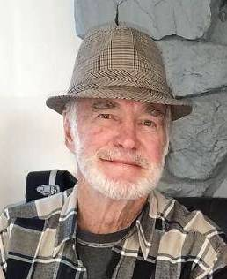

⁕⁕⁕⁕⁕⁕⁕⁕⁕⁕⁕⁕⁕⁕⁕⁕⁕⁕⁕⁕⁕⁕⁕⁕⁕⁕⁕⁕⁕⁕⁕⁕⁕⁕⁕⁕⁕⁕⁕⁕⁕⁕⁕⁕⁕⁕⁕⁕⁕⁕⁕⁕⁕⁕⁕⁕⁕⁕⁕⁕⁕⁕⁕⁕⁕⁕⁕⁕⁕⁕⁕⁕⁕⁕⁕

WHAT’S THE HAPS?

⁂ Millicent Cook made her transition on April 5th. Tom is now living in Los Angeles. There
will be a Celebration of Life up here in Big Bear on July 23rd. Details will be given in the
. June Newsletter. If you’d like info about Tom, please contact Ellen Kesler.

⁂ Ellen Kesler is having a huge garage sale on May 26 - 28th at 550 E. Fairway Blvd., Big Bear
City. Camping equipment, some furniture, house flags, clothing, etc.

⁂ On May 19th, the Big Bear Group of the Sierra Club will have their monthly General Meeting in the
Bridges Presbyterian Church, 579 Knickerbocker, Big Bear Lake at 6:30pm. The speaker will be
Ed Wallace presenting the Pebble Plains - we’re the only place in the World where these are located!
Everyone is welcome and it’s free!
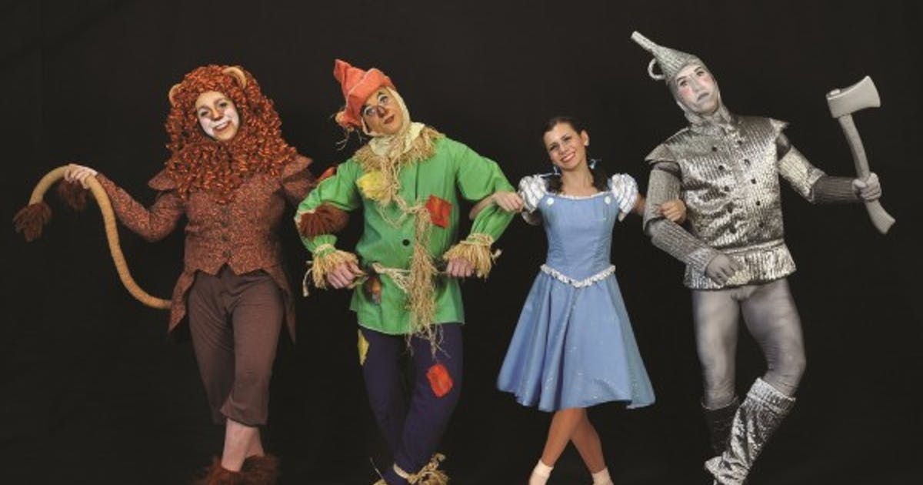
SPIRITUAL LESSONS FROM THE WIZARD OF OZ

I am excited to announce the second class to complete my Mindful Meditation Teaching Certificate.
YEA!

“Spiritual Lessons from the Wizard of Oz” will be online this time.
The classes are on June 4, 11, 18, and 25, 2022, from 9:30 to 11:00.
We will explore how Dorothy, the Scarecrow, Tin Man, and the Cowardly Lion all have lessons from which we can learn. There is even a lesson from the Yellow Brick Road.
The class is limited to 15 to 20 people because I want to see all of us on one page.
The cost will be $10.00 for each class. I will have VENMO set up for payment for those who want to pay that way.
I will be emailing the handouts to you for you to print out.
Please let me know if you are interested in this class. This invitation goes out first to folks who have taken classes before and those who have expressed interest.
I look forward to hearing from you!

Best wishes, Liz Harris

THE ART OF INSPIRED LIVING
By Rev. Karen Wylie

So much is happening on the planet right now, much of which is very upsetting. As I watch the evening news, I am provided with lots of prayer work. What is happening for me, and apparently so many others, is that my heart is filling with unbelievable compassion. It is coming from the deepest part of me. This compassion seems to be awakened now in human beings in every corner of the world. As we watch what is unfolding in the Ukraine, we are getting to see firsthand the pain of war; the pain of separation.
I focus on this awakening of compassion, which seems to be showing up everywhere, no matter the nationality. We never know why anything happens the way it does. We never know the good that comes out of events that on the surface seem to be humanly so wrong. I discover that no matter the situation, my job is always to find the place of healing within myself that allows me to see the blessing in what appears to be catastrophe. In that way, I become a contributing force for good, not just for myself, but also for the whole human family.
Healings happen in the light of love and compassion. It is that compassion that brings us peace individually and unites us all over the world as one people, inseparable one from another. And so, as I watch the news, as the events of the day unfold before me, I remember the essence of me; that part of me that can find a greater truth no matter the situation, and the peace and compassion within me for all humanity magnifies.
Remember this; you are the light and love that so many of us need during this time of great transition on the planet. You are the promise of a great tomorrow!

In peace and love.


COMPASSION PRAYER

May all people suffering from home displacement know comfort.
May all people who are injured as a result of war know healing.
May all people who are motivated to wage war know the ability to re-think their actions.
May all people who are living in peace hold those who are not, in their hearts

May all people realize we are one.



AKASHIC PRAYER FOR CREATING HEAVEN ON EARTH

As I integrate the power of the soul with the power of the body,
I manifest with ease and grace.
I am a Creator Being with a purpose.
I am now creating heaven on Earth.
I am blessed and filled with gratitude..
So it is. Blessed Be.



TACOS WITH A PURPOSE

Mark your calendars to come to our Big Bear Valley Historical Society’s
Fundraiser on Monday, May, 23rd, noon until 8:30 p.m. at Sonora Cantina, at 41144 Big Bear Blvd, Big Bear Lake.
The delicious tacos are only $1 per taco, and you will have a choice of Ground Beef, Chicken, Pork, Shredded Beef, and or a Veggie Taco! AND.... if you can come, you won’t have to cook or clean up after lunch or dinner!
We will have an exciting Opportunity Drawing and a Silent Auction. All the proceeds will go to our Big Bear Museum, so we will be able to continue to keep up the maintenance and operations of the museum. Any amount that can be donated to our Big Bear Valley Historical Society will be so appreciated.
Thank you in advance for your support to and for our Big Bear Museum.

Gloria Meade





