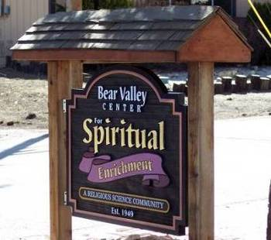
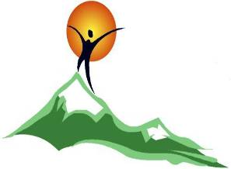

Bear Valley Center for Spiritual Enrichment

A Religious Science Community
“Open at the Top”
SEPTEMBER 2021
Newsletter

Sunday Services, 11:45 a.m. Now meeting at Bridges Presbyterian Church building

579 Knickerbocker Rd., Big Bear Lake, CA 92315

Mailing address - P. O. Box 4184, Big Bear Lake, CA 92315
, Email:bvcse2000@gmail.com Website: www.bvcse.org
501C3 tax ID #95-3685187
Our purpose is to inspire and nurture spiritual growth by accepting a loving, all-inclusive community through teaching, healing, and serving, for the highest good of all.
We are the Mind of God knowing, the Heart of God loving, and the Hands of God serving.

Newsletter staff: Editor, Ellen Kesler – Assistant Editor, Julie Grandi
Newsies – Mac & Hamish Kesler & Baby Face

September Topics and Speakers

September 5th Rev. Michael Curcuru
“Piano Lessons”

September 12th Janet Grace Nelson, RScP
“Love More…Fear Less”
September 19th Rev. Dr. Jerry Troyer
“The Experience of
Enoughness”

September 26th Rev. Ali Benjamin

“Sensitive is the New

Strong”

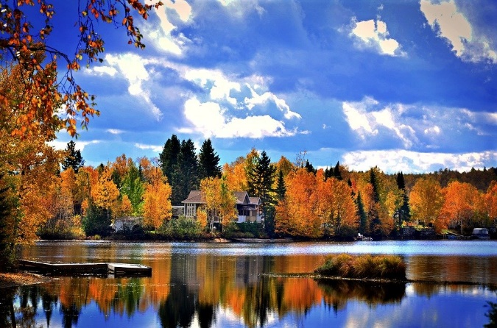

September Calendar
September 5th - - Service begins 11:45am
(Live on Facebook & IN PERSON!!)
(Now at Bridges Presbyterian Church,
579 Knickerbocker Rd., Big Bear Lake)

September 6th – LABOR DAY

September 12th - Service begins 11:45am
(Live on Facebook & IN PERSON!!)
- Board of Trustees meeting, 2pm

September 19th - Service begins 11:45am
(Live on Facebook & IN PERSON!!)
Rev. Dr. Jerry Troyer’s workshop following service “Healing Our relationship with Money” Cost $20

September 22nd - AUTUMN BEGINS

September 25th - Deep Meditation with Liz Harris, 9:30am – 11:30am on Zoom * please contact Liz at pokeyandliz@gmail.com for the Zoom link

September Calendar (cont’d)

September 26th - Service begins 11:45am
(Live on Facebook & IN PERSON!!)

September 27th Combined Sacred Circles,
Nancy Walker, Leader – meet at Bridges, 2pm



ATTENDANCE…

Have you been attending online? You can go to:
Bear Valley Center for Spiritual Enrichment
on Facebook

You can see all the recorded services by either going to our website or our BVCSE YouTube channel.

Birthdays!

9/3 - Lorraine Taylor
9/4 – Noreen Caswell
9/15 – Janet Grace Nelson



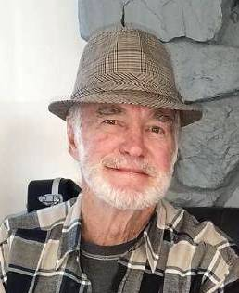

AN “ARTISM”

“Don’t Panic”

Can we realize that what is happening in our world right now is our life situation, but it is NOT our life? Remember, we are “spiritual beings having a human experience,” so could it be that things are not falling apart; things are falling into place? Maybe this is our opportunity to learn to trust the love that defines us, and as that love reveals our destiny, to love and be loved in return.
Imagine realizing that if we have a pulse, we have a purpose to help others. Know that God is for us, therefore, who or what can be against us!?
My folks taught me bits of Biblical wisdom like, “You have not, because you ask not”. So, let’s ask, and then declare, that truth is being uncovered and the source of our being is saying, “Don’t panic – be happy!”

Namastѐ, Art Harriman

OUR 2021 BOARD OF TRUSTEES!

President – Eloise Lepore
Vice President – Nancy Walker
Secretary – Margo Penardi
Treasurer – Mindy Mathewson

Members-at-Large – Michael Benjamin
Lorraine Taylor

Inspirational Article

“LOVE More…Fear Less”

“The more you are motivated by Love, the more fearless and free your action will be,” ~ Dalai Lama.

We are all navigating through a new terrain in life and fear has been even more present in our lives. This invites us to look at from where we are making our choices and decisions; Love or Fear? It is more important now than ever to connect to our hearts and listen to our inner wisdom that wants to guide us. Love, the energy of expansion, is here to show us how to know what choices are right for us.
We have been given this beautiful opportunity to take “time out” for some “time in” and establish an even more intimate relationship with our Higher Self that is always directing us for our highest good. This is an opportunity to live from “Love” and above (Harmony, Peace & Joy) in every area of our lives. “Love” is the energy of expansion and always feels uplifting, joyful, and exciting. “Fear” is the energy of constriction and it feels heavy, anxious, and chaotic. We can discern which energy is pulling us if we have a deeper understanding of ourselves and awareness of what’s steering us.
One of the most important spiritual practices to engage in is meditation. Take some time each day to meditate (quiet your mind and open your heart). You can do this first thing in the morning as you are just waking or you can go on a silent walk and let yourself feel your connection to your heart. This is an essential practice in building this relationship with you and your higher self (God/Love). Keep opening your heart more every day as you listen for all the ways you can BE more of your true self and give from Love, Kindness & Compassion in all the ways you are shown.
The guidance that comes from your Higher Self will always make you feel better, more alive and your nervous system is your greatest barometer to let you know you’re on the right track. As you start paying attention to how you’re feeling, you will know which voice is guiding you and you can then adjust your thinking accordingly. Let your knowing heart instruct your thinking mind which path to take; it will always feel better.
Then as you are asked to share your thoughts and beliefs about what is happening in the world, let your knowing heart share its voice from a place of Love. This truly is an act of Love for yourself, your loved ones, and the world as you come to BE the presence of Love more and more every day.

Loving & Living & Leading from “Love”
& serving others to do the same!!!
Janet Grace Nelson

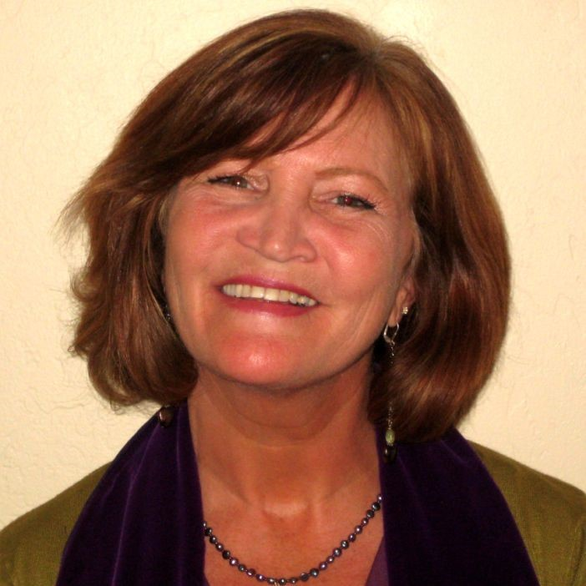

AKASHIC PRAYER OF SELF-TRUST

Mother, Father, Goddess, God, I awaken to the memory of the ancient soul
I AM.
With this memory, I know I can trust myself and my inner guidance.
I am a divine soul having a human experience and it is good.
.
So it is. Blessed Be.

(Akashic Records are the records of your soul’s journey, from the time you first arise from Source
until you eventually return home. For more info, go to www.AkashicKnowing.com)

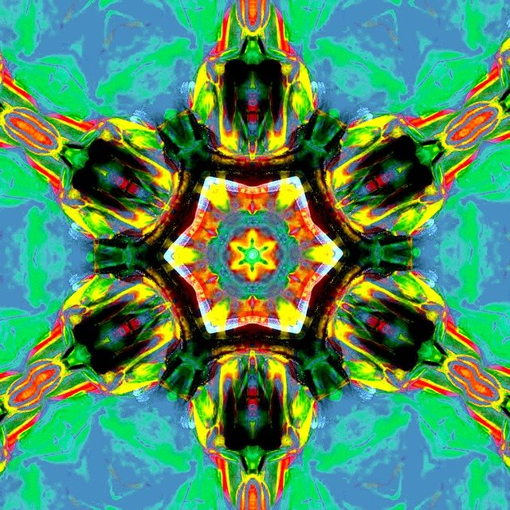

SPEAKERS & TOPICS for September

September 5 - Rev. Michael Curcuru “Piano Lessons"

This week, Rev. Michael will share his insights on the Science of Mind “Principle of Oneness”. "Are you in tune with the Infinite?" Rev. Michael will discuss how we can do just that!

September 12 - Janet Grace Nelson
“Love More, Fear Less”

We are navigating through a new terrain in life, and fear has been even more present in our lives. This invites us to look at where we are making our choices and decisions from; fear or love? It is more important now than ever to connect to our hearts and listen to our Inner Wisdom that wants to guide us. “Love”, the energy of expansion, is here to show us how to know what choices are right for us.

September 19 - Rev. Jerry Troyer
"The Experience of Enoughness"

Very often we might start our days with "not enough." not enough sleep, not enough coffee, not enough time. That consciousness could extend to thoughts about ourselves: I am not enough, I don't do enough, I don't have enough. But it's our story, and it's sticking to us! Can we, and if so, how do we, change our story, and our experience, into "enoughness?"

Join us after service, for Rev. Dr. Jerry's brand-new workshop, "Healing Our Relationship with Money."
Cost - $20

September 26 - Rev. Ali Benjamin
“Sensitive is the New Strong”

Rev. Ali shares insights on the gift of sensitivity and how it can open you up to your spiritual superpowers and bring great joy and deep meaning to your life and relationships. “Being an empathetic person has allowed me to be tuned in to life on a very deep level: I feel the energy in a room, other people's emotions, and have intuitive insights about people, places, and things. It hasn’t always been easy and I have learned some painful lessons along the way, but today I know that being a highly sensitive person is a blessing,” Rev. Ali.

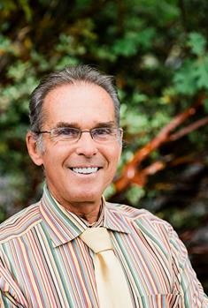
Rev. Michael Curcuru

Janet Grace Nelson

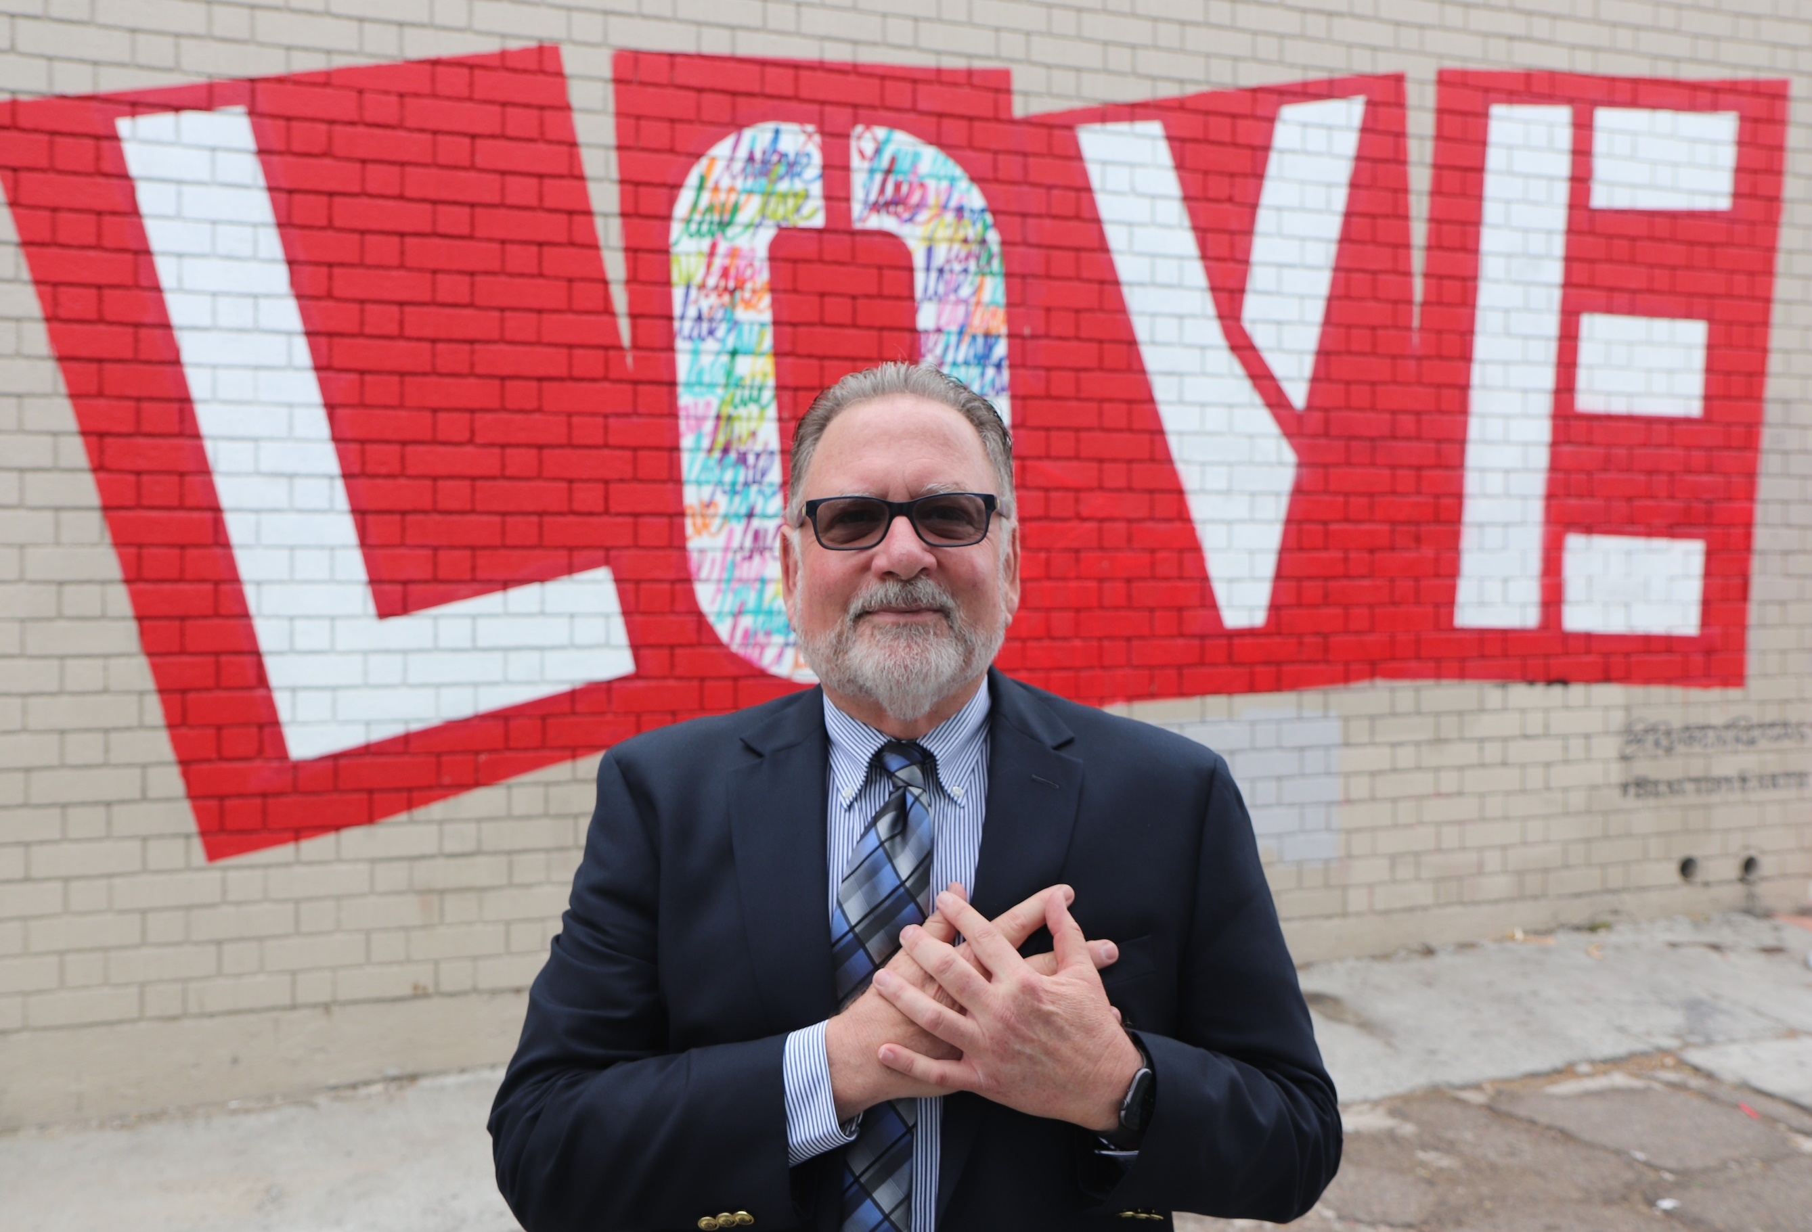
Rev. Dr. Jerry Troyer

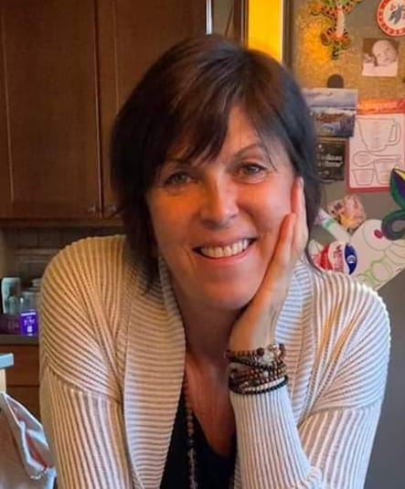
Rev. Ali Benjamin

Board Article

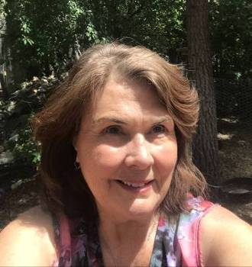

This month, instead of writing an article, I would just like to share this poem with you. I hope you enjoy it as much as I did.
Eloise Lepore, President, Board of Trustees

“The Invitation”

By Oriah Mountain Dreamer, Hope Indian Elder 05/1994

It doesn’t interest me what you do for a living.
I want to know what you ache for,
and if you dare to dream of meeting your heart’s longing.

It doesn’t interest me how old you are.
I want to know if you will risk looking like a fool for love,
for your dreams, for the adventure of being alive.

It doesn’t interest me what planets are squaring your moon.
I want to know if you have touched the center of your own sorrow,
If you have been open by life’s betrayals or
have become shriveled and closed from fear of further pain.

I want to know if you can sit with pain, mine or your own,
without moving to hide it or fade it or fix it.
I want to know if you can be with joy, mine or your own;
if you can dance with wildness and let the ecstasy fill you

to the tips of our fingers and toes without cautioning us to be
careful, be realistic, or to remember the limitations of being human.

It doesn’t interest me if the story you are telling is true,
I want to know if you can disappoint another to be true to yourself.
if you can bear the accusation of betrayal and not betray your own soul.

I want to know if you can be faithful and therefore trustworthy.
I want to know if you can see beauty, even when it is not pretty every day,
and if you can source your life from its presence.

I want to know if you can live with failure, yours or mine,
and still stand on the edge of a lake and shout to the silver of the full moon, “Yes!”

It doesn’t interest me to know where you live or how much money you have.
I want to know if you can get up after the night of grief and
despair, weary and bruised to the bone, and do what needs to be done for the
children.

It doesn’t interest me who you are, or how you came to be here…
I want to know if you will stand in the center of the fire with me and not shrink
back.

It doesn’t interest me where or what or with whom you have studied.
I want to know what sustains you from the inside when all else falls away.
I want to know if you can be alone by yourself,
and if you truly like the company you keep in the empty moments.










