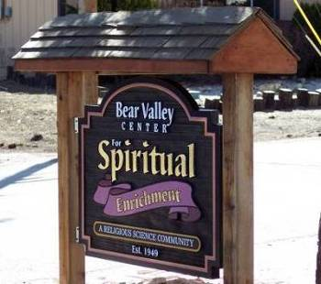
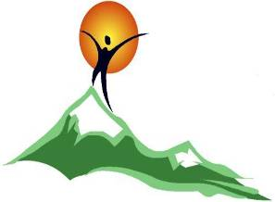

Bear Valley Center for Spiritual Enrichment

A Religious Science Community
“Open at the Top”
APRIL 2021
Newsletter

Sunday Services, 10:30 a.m. 578 Bonanza Trail, Big Bear Lake

P. O. Box 4184, Big Bear Lake, CA 92315
909-866-7100, Email:bvcse2000@gmail.com Website: www.bvcse.org
501C3 tax ID #95-3685187
Our purpose is to inspire and nurture spiritual growth by accepting a loving, all inclusive community through teaching, healing, and serving, for the highest good of all.
We are the Mind of God knowing, the Heart of God loving, and the Hands of God serving.

Newsletter staff: Editor, Ellen Kesler – Layout Manager, Julie Grandi
Newsies – Mac & Hamish Kesler & Baby Face

M

April Topics and Speakers

April 4th Rev. Dr. Carol Lawson
“Rise Up: Celebrating Easter”

April 11th Rev. Jean Sweet
”The Principles of Organic
Farming”

April 18th Rev. Ali Benjamin
“Spiritual Resilience”

April 25th Rev. Dr. Jerry Troyer

“Honoring the Earth-

And Its Residents”

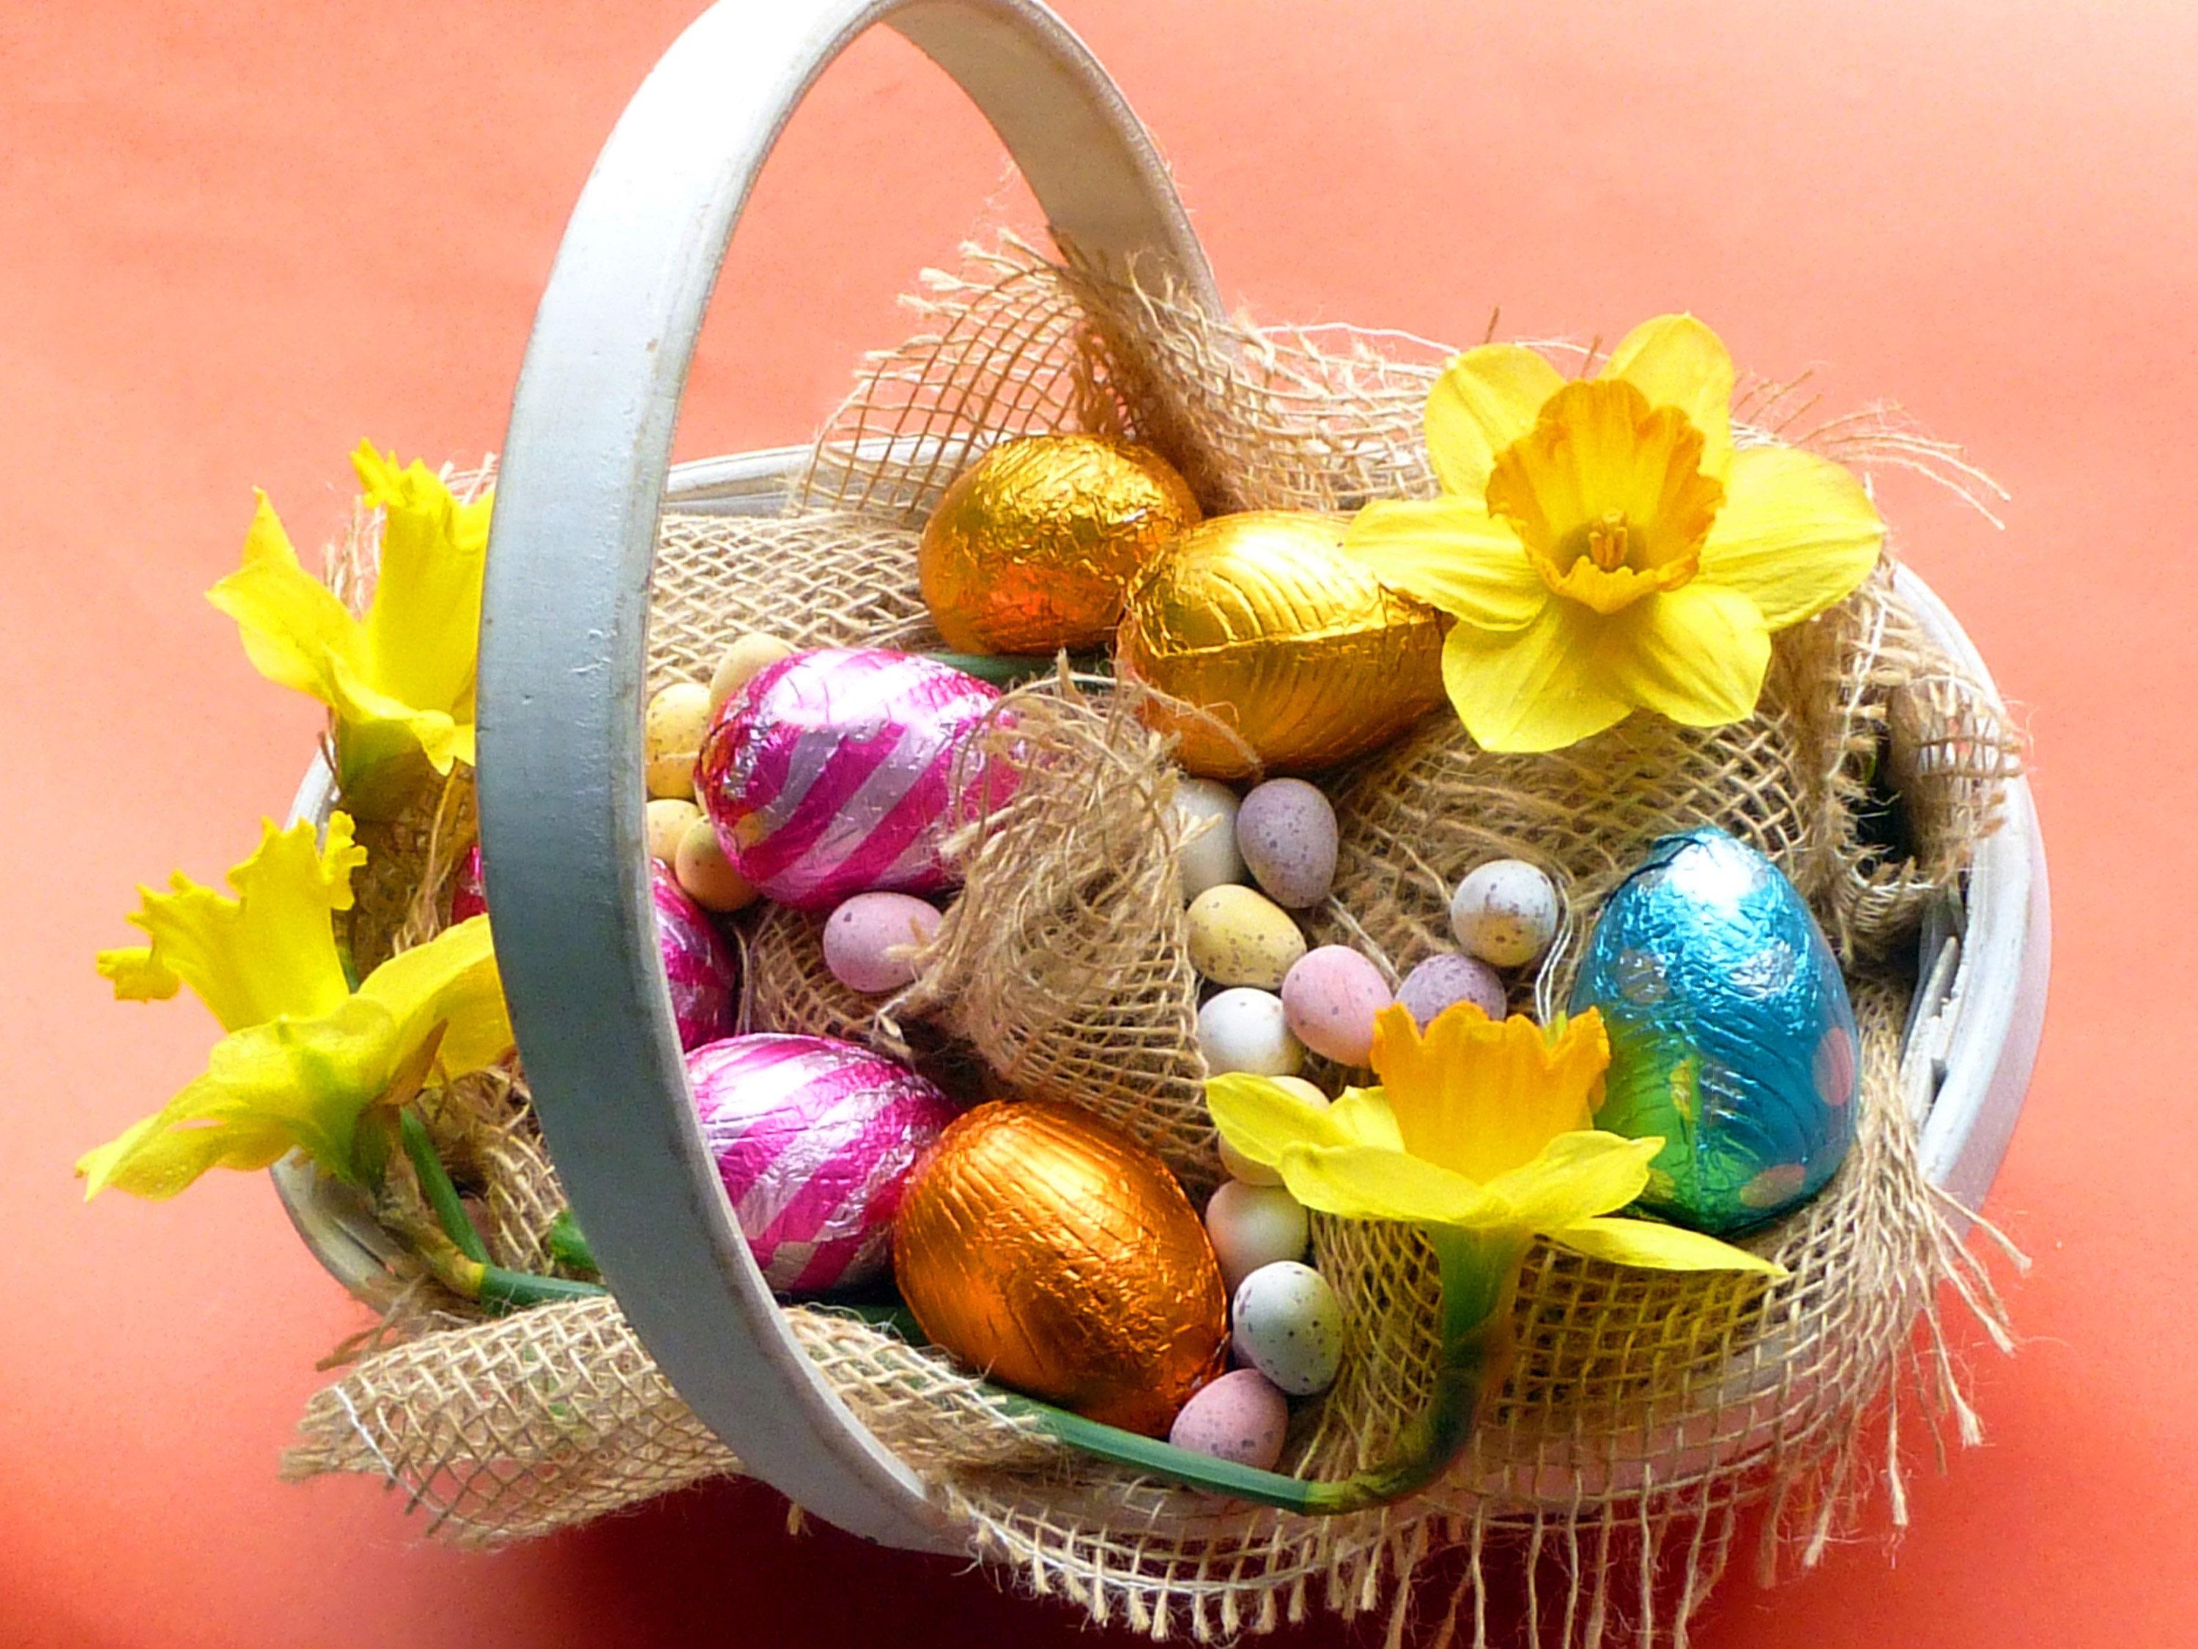

April Calendar

April 1st – APRIL FOOL’S DAY
April 2nd – GOOD FRIDAY
April 4th - EASTER

April 4th 10:00 - 10:20 a.m. Guided Meditation
10:30 a.m. Service begins
(Live on Zoom)

April 7 ^{th} 10:00 a.m. Guided Meditation w Michael Benjamin ( Live on Zoom)

April 11st 10:00 - 10:20 a.m. Guided Meditation
10:30 a.m. Service begins
(Live on Zoom)
12:00 pm
Board of Trustees meeting
Via Zoom

April 14th 10:00 a.m.
Guided Meditation w Michael Benjamin
Live on Zoom

“In La Kesh” Sacred Circle
Michael Benjamin’
(Leader via Zoom)

April Calendar (continued)

April 18th 10:00 - 10:20 a.m. Guided Meditation
10:30 a.m. Service begins
(Live on Zoom)

April 21st 10:00 a.m. Guided Meditation
w Michael Benjamin
(Live on Zoom)

April 22 – EARTH DAY

April 24th -* Deep Meditation with Liz Harris, 9:30am – 11:30am on Zoom
* please contact Liz at
pokeyandliz@gmail.com for information about this month’s event

April 25th 10:00 – 10:20 Guided Meditation
10:30 Service begins
(Live on Zoom)

April 26th “Delightful Deliberate Creators”
Sacred Circle, Nancy Walker, Leader
(Live on Zoom)

April 28th 10:00 a.m. Guided Meditation
w Michael Benjamin
(Live on Zoom)

ATTENDANCE…
Have you been attending online? You can go to:
Bear Valley Center for Spiritual Enrichment
on Facebook or get the Zoom connections on Facebook for our website and join “in person”

You can see all the recorded services by either going to our website or our BVCSE YouTube channel.

Birthdays!

4/9 – Rev. Ali Benjamin
4/12 – Susan Conley
4/15 – Millicent Cook
4/16 – Kristan Johnson
4/17 – Joan Cline
4/27 – Bruce Smith
4/29 – Sally Markey



EASTER BOUQUET

- Beverly J. Anderson

A vision of spring passed my way
in a form of an Eastertime bouquet –
Forget-me-nots of powder blue,
roses sweet of every hue,
daffodils of sunny gold,
all so lovely to behold.

Lavender lilacs, daisies of white,
tulips too in colors bright,
pink sweet peas, and pansies gay –
all on parade this Easter Day.

From childhood’s garden of flowers and lace
and an angel smile upon each face –
joyful, frilly little girls
with shining eyes and golden curls
form an Eastertime bouquet,
dressed in Sunday-school array.

Board Article
“Just watching an animal closely can take you out of your mind and bring you into the present moment, which is where the animal lives all the time -- surrendered to life.”
Eckhart Tolle
Maybe this is why I find such peace and pleasure volunteering at the Grateful Heart Animal Sanctuary - surrendered to life.
“Schnookums” (front pig), came to the Grateful Heart Animal Sanctuary after being kept in a small crate in an apartment for so long that one of his legs had not developed completely. With no exercise and an underdeveloped leg, he could not walk properly. At the Sanctuary, he was given a blanket and freedom to move about. No more crates. As his strength improved, he let Julie Sifter (owner) know he longed to be outside with the other animals. This being his first opportunity to socialize with other animals, we were thrilled to see him develop a bond with sweet “Tilly”. He still limps, but roams the farm with other pigs, many goats, a cow and dogs. I am reminded daily of the words of the Dalai Lama, “Life is as dear to a mute creature as it is to man. Just as one wants happiness and fears pain, just as one wants to live and not die, so do other creatures.”
“Schnookums” is just one example of the transformation that I have been able to witness. Each rescue at the farm has a story. As we interact in a way beyond thinking, we get to experience the change in the animal- and consequently a change in ourselves.
This is where I go to spend quiet time and experience the healing nature of these beautiful creatures, look deep into their eyes, and feel their living soul.
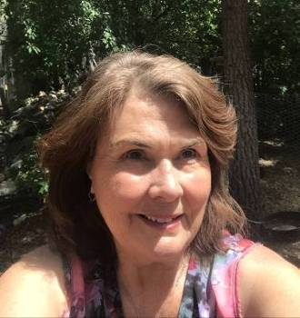
Eloise Lepore, Board Member-at-Large

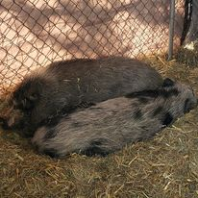
Schnookums and Tilly
ANNUAL MEMBERS’ MEETING,
MAY 2ND, 2021

Greetings to all you beloved BVCSE friends out there. As we are gearing up for the next phase in our evolution as a Center, we are enthused to be closing the door on the COVID chapter of our existence. We look forward to opening up to what is seeking to emerge for us as a Spiritual Community. We have set the date for our in-person services re-opening as Sunday May 2, at 11:30 am. Surely, this will be enough time for our membership to have received full vaccination, and we believe we can safely and responsibly resume in-person services. We will be requiring masks to be worn for our service. YEA, YIPEE, HOOT, HOOT!
We urge you to make this especially important service a priority, as it is not only our first in-person Sunday service, it is our Annual Membership Meeting, with important topics to cover as a community. Additionally, if you feel called to join the Board of Trustees at this time, please notify one of us as soon as possible. We would love to have you join us.
To reiterate the obvious, we are a volunteer board of loving friends and supporters of the BVCSE. Being volunteers and loving supporters of our BVCSE does not change our responsibilities to manage the physical business affairs of our Center. This annual meeting is as important as any. We need to evaluate and navigate the future of our BVCSE, and this should be done together as a community. Please join us on May 2nd.

Peace and Blessings to you all.
Your Board of Trustees,
Michael, Nancy, Margo, Mindy, and Eloise

SPEAKERS & TOPICS for APRIL

April 4th - Rev. Dr. Carol Lawson “Rise Up: Celebrating Easter”
As we open to the invitation to claim rebirth and renewal for ourselves in this Easter time, we are called to “Rise Up” -- rise up in consciousness, in setting our daily intentions for ourselves, and to rise up in service to ourselves and our world. These are the times; we are the people. Let's rejoice together.

April 11th - Rev. Jean Sweet “The Principles of Organic Farming”
The principles have a lot in common with the metaphysical principles of growing your dreams. Guest speaker Rev. Jean Sweet Zooms in from Helena, MT to weave them together. As the first, and so far only, Farmer Minister in the Affiliated New Thought Network, she is insistent that we grow good for all living things.

April 18th - Rev. Ali Benjamin- “Spiritual Resilience”
As spiritually awake and aware individuals, we are being called to “step up and step out” and to support humanities evolution. We all want peace, love, and understanding, and it’s time to be way-showers and lead by example. We don’t have to learn how because our soul already knows how! We simply rely upon our soul's wisdom, power, and resilience. We were made for these times!

April 25 - Rev. Dr. Jerry Troyer- "Honoring the Earth--and Its Residents"
We celebrate Earth Day on April 22nd, encouraging awareness of our planet, conservation, recycling
and wise-use of our natural resources. But how do we co-exist with the other residents? Do we recognize each person as the beloved, including ourselves, or does our “story” get in the way?

MEET OUR NEWEST SPEAKERS

Rev. Dr. Carol Lawson is the Founder and Spiritual Director for 29 years of the Center for Conscious Living, Moorestown, NJ. A recognized scholar and long-time practitioner of the teachings of New Thought and Science of Mind, Rev. Dr. Carol has served as Board member and President of the Affiliated New Thought Network, on the faculty of Emerson Theological Institute, and on the Advisory Council of Association of Global New Thought. She holds a Doctorate of Divinity from Emerson Theological Institute, and a Master of Science from the University of Southern California. She is a Woodrow Wilson Fellow, and taught at Cal State University, Los Angeles before becoming ordained as a Religious Science Minister. Jean Houston calls Carol “a luminous lady of spirit, a true wise woman for our time.”

Rev. Dr. Jerry Troyer holds a Masters Degree in Religious Studies, and a Doctorate of Divinity, from Emerson Theological Institute. He lives in La Mesa, California (near San Diego) with his beloved Golden Retriever, Maggie. In 2016, Rev. Jerry was named Director of Shelter Operations for Urban Street Angels (USA), working to coordinate weekly shelters for homeless transition-age youth, where guests could receive dinner, a shower, and a warm and safe place to sleep. The shelter program has since ended, and Jerry now works with USA as Director of Relationship Development. In 2018, he joined the staff of Om Center for Spiritual Living as a staff minister. He speaks there regularly, as well as other Unity, Centers for Spiritual Living, and other communities across the country.

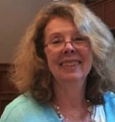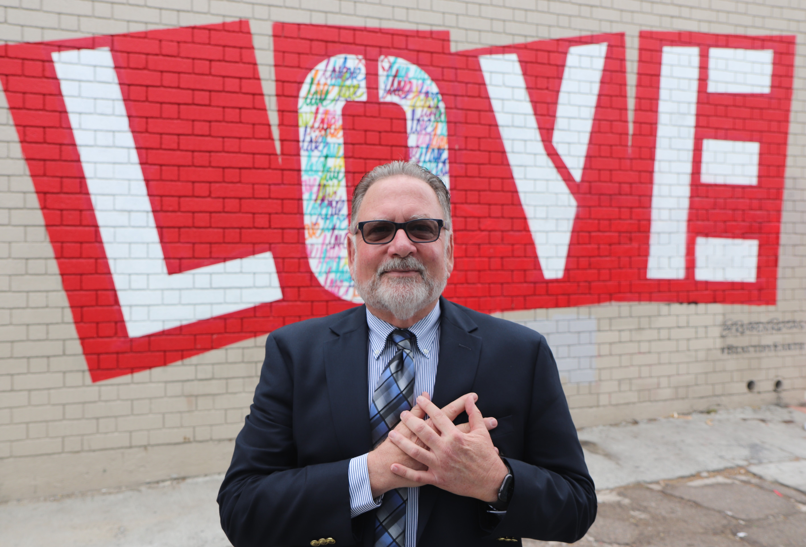

Rev. Dr. Carol Lawson Rev. Dr. Jerry Troyer

Inspirational Article

As spiritually awake and aware individuals, we are being called to “step up and step out: to support humanities evolution. We all want peace, love, and understanding and it’s time to be “way-showers” and lead by example. We don’t have to learn how because our soul already knows how! We simply rely upon our souls’ wisdom, power, and resilience. We were made for these times!

Resilient people -
- know that we all travel complicated lives, we all have imperfect lives, we all face something, and we all have a well of resilience within us.

- take responsibility for their lives, choices, decisions, and actions.

- are positive, sense what’s possible, and see the glass half-full.

- are respectful to themselves and others; they honor all sentient beings.

- know that energy flows where their attention goes; they understand that clear intentions pave the way to contentment and create balance and harmony.

- work through their challenges with compassion and wisdom.

- are adaptable; they can pivot when life demands it, and understand flexibility is key to the creative process and positive outcomes.

- have the ability to question their thoughts, question their assumptions, and to do a pattern interrupt when moving down a menacing mental track.

- see their strengths and lean into them.

- have a support system, stay connected with their tribe, and they know when to ask for help.

- understand the magic of friendship.

- know that it’s “ok” to not know. They are open to learning and growth.

- take care of themselves and have compassion for themselves and others.

- meet others where they are, listen to other’s stories, and extend loving kindness.

- understand that they may have childhood wounds, unprocessed trauma - most people do. They are willing to do the healing work to address these wounds, repair, and renew.

- know that healing is a journey, not a destination.

- manage their fear, greet it, listen to it, learn from it, and transmute the energy into love and appreciation.

- know that shame is an illusion, a dark thought form, a projection; it’s not who they are, and can be released.
- know when there has been a misunderstanding, to flip the script, and to say “sorry” for their part.

- know to forgive themselves and others, release the past, and set themselves free.

- know that breakdowns are often breakthroughs and opportunities for growth and spiritual evolution.

- move beyond the difficulties they are facing, they don’t let them flatten them, and they keep going.

- are mindful and understand their thought patterns and know their body’s energy and rhythms.
are self-aware and understand that they impact others and the world.

- know that they are a light in the world and they know that wherever they go and whomever they are with, to shine and share that light.

- know that they are a resource; there is innate wisdom within them, and they nurture this communion.

- use their creativity in service of their dreams and in service of humanity.

- know that they are sovereign beings - they trust themselves, they trust their discernment, and trust their intuition.

- know that each day is brand-new, that anything is possible, and that they are motivated and equipped to not only survive, but to thrive.

- know they are part of something larger - one life, one power, one infinite organizing intelligence: that life is interconnected, interrelated, and interdependent and draw strength, understanding, and guidance from this one.

- ask themselves, “What do I want to contribute to life today?” “What wants to be birthed through me that will elevate all life today?”
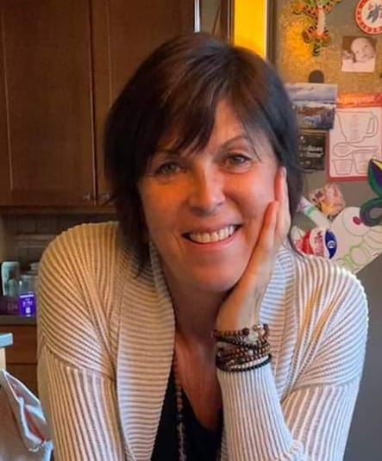 Love, peace, and blessings, Rev. Ali Benjamin

ELK’S CALL

FREEDOM FROM FEAR

Every truth has within it the power of fulfillment –

Can we imagine that the love that defines us, is Light, and Fear is Darkness? Can we also imagine that the light of our true identity does not support darkness? Thus, our Light dispels the Darkness….
An example could be Love replacing Fear – if I am afraid that I may be prejudice, a mindset that can be explored and resolved with the healing essence of Love, using the two greatest Biblical encouragements; “Love God above all things” and the second is, “Love your neighbor as yourself, FOR the Love of God.” When we love our neighbor, whether they are loving or not, we are being served by the Source; it’s addressed to the Spirit and it’s a circulation that we’re setting off. When we love others, we receive the love that allows us to do that.
Understanding these truths, frees us from an unhealthy need to be controlled by false beliefs of supremacy.
I enjoyed this simple journey from unconscious to conscious, fear to love, with an approach of;
Face it,
Trace it,
Embrace it,

Erase it,
And Replace it!
Now, it’s all about Love.

When we make a choice to be free of Fear, then that choice makes us…free of fear!
Namastѐ, Art Harriman

(Editor’s note: Art had this insight in response to a very deep discussion we had at our Waking Crew meeting on March 21st where we discussed the racism in America. Katherine shared a book she read, and highly recommends reading, Caste by Isabel Wilkerson. Talks about the castes in America.)

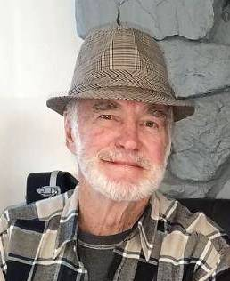

AKASHIC PRAYER TO RELEASE JUDGMENT
Mother, Father, Goddess, God, when I judge myself or others, I feel my energy spiral down.
I AM ready to release all judgments and stand in Truth, supported by Love.
Help me ro recognize the perfection of me as I am, as well as the perfection of all creation in this moment.
Help me to develop in compassion and discernment. I AM grateful for this opportunity to grow.
So it is. Blessed Be.
- Akashic Knowing School of Wisdom

- (Akashic Records are the records of your soul’s journey, from the time you first arise from Source until you eventually return home. For more info, go to www.AkashicKnowing.com)

  Covid puzzle solving Dachsund Love
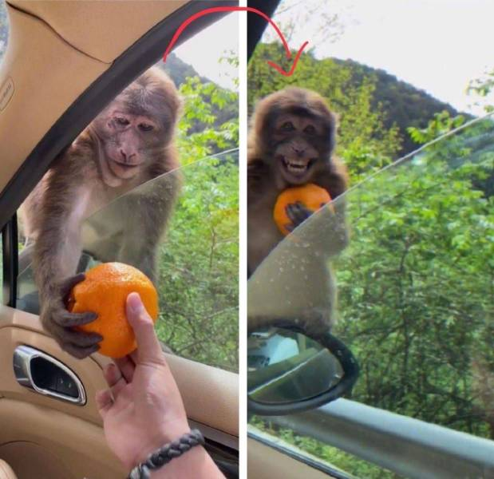

THOUGHTS TO PONDER

⸙ Why do supermarkets make the sick walk all the way to the back of the store to get their prescriptions
while healthy people can buy cigarettes at the front?

⸙ Why do banks leave vault doors open and then chain the pens to the counters?

⸙ Why don’t you ever see the headline “Psychic Wins Lottery”?

⸙ Why is the person who invests all your money called a “broker”?

⸙ Why is the time if day with the slowest traffic called, “Rush hour”?

⸙ Why didn’t Noah swat those 2 mosquitoes?

⸙ You know that indestructible black box that is used on airplanes? Why don’t they make the whole plane
out of that stuff?

⸙ Why don’t sheep shrink when it rains?

⸙ Why are they called “apartments” when they’re all stuck together?

⸙ If flying is so safe, why do they call the airport, the “terminal”?


