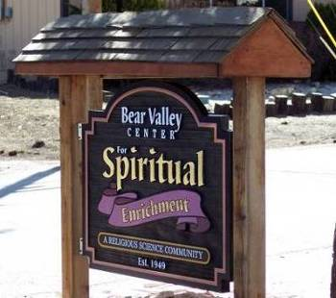


Bear Valley Center for Spiritual Enrichment

A Religious Science Community
“Open at the Top”
FEBRUARY 2022
Newsletter

Mailing address - P. O. Box 4184, Big Bear Lake, CA 92315,

Email:bvcse2000@gmail.com Website: www.bvcse.org

501C3 tax ID #95-3685187
Our purpose is to inspire and nurture spiritual growth by accepting a loving, all-inclusive community through teaching, healing, and serving, for the highest good of all.
We are the Mind of God knowing, the Heart of God loving, and the Hands of God serving.

Newsletter staff: Editor, Ellen Kesler
Newsies – Mac & Hamish Kesler

⁕⁕⁕⁕⁕⁕ ANNOUNCEMENT FROM THE BOARD OF TRUSTEES ⁕⁕⁕⁕⁕⁕

The Bear Valley Center for Spiritual Enrichment is on the growing edge of our continued intention to provide inspiration and support to our congregation.
In February, we are implementing a new format for our beloved Center and no longer be holding Sunday services; on Thursdays, beginning Feb. 3rd, at 1:00, we will start a new “Conscious Living Study Group”. For now, we will be on Zoom until it is deemed safe to meet in person again. We will post the Zoom link on Facebook weekly and hope you will join us. Each week, we will “check in” with one another, have a meditation, then a book discussion. It should last between 1 ½ - 2 hours. We will begin by reading the book, I Am The Word , by Paul Selig. Please read the Foreword, Preface, and the first 72 pages of the book before our first meeting. Don’t feel intimidated - it is fast reading! We will also plan, as a group, to gather in each other’s homes for occasional potlucks, and plan other social activities for our spiritual family.
I look forward to seeing you all there.
Love and Blessings,
Nancy Walker

Calendar
February 3rd - - “Conscious Living Study Group”, 1pm ON ZOOM - go to BVCSE Facebook for
Link*
February 10th - “Conscious Living Study Group”, 1pm ON ZOOM - go to BVCSE Facebook for
Link*
February 14th - VALENTINE’S DAY
February 16^{th -} Board of Trustees meeting, 1pm ON ZOOM
February 17th - “Conscious Living Study Group”, 1pm ON ZOOM - go to BVCSE Facebook for
Link*
February 19^{th -} Deep Meditation with Liz Harris, 9:30am – 11:30am on Zoom please contact Liz at pokeyandliz@gmail.com for the Zoom link
February 21st - PRESIDENTS’ DAY
February 24th - “Conscious Living Study Group”, 1pm ON ZOOM - go to BVCSE Facebook for
link*
February 28th - Sacred Circle, Nancy Walker, Leader - ON ZOOM

ATTENDANCE…

*To attend the Conscious Living Study Group and get the Zoom link, you can go to Bear Valley Center for Spiritual Enrichment on Facebook

Birthdays!

2/6 – Marv Cira
2/9 - Sandy Morrell-Lucia
2/19 - Fran Fish

“When I was a boy of 14, my father was so ignorant I
could hardly stand to have the old man around. But
when I got to be 21, I was astonished at how much the
old man had learned in seven years.”
-Mark Twain

Inspirational Article

“The Love That Defines Us”

Imagine that the love that defines us can do anything but fail. This is so important because failure is really just a lack of knowledge - our true identity as spiritual beings, having been made in the image and likeness of God our Maker, is always positive. As an example, the Grace of God put understanding on my heart relative to negative and positive. Negativity is the activity of inner misery; it blinds us to what defines us and what could be. Positivity is the activity of inner victory; it reminds us of what defines us and sets us free to be what God intended for us to be. Cultivating understanding of this truth, is like unlocking the gate to a heart full of Grace and simply learning that God needs an outlet. We have been blessed to have been chosen. So, the love in me praises, honors, and glorifies the love in you.
Namastѐ, Art Harriman 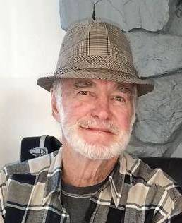


AKASHIC PRAYER TO BE OF SERVICE

Mother, Father, Goddess. God. I am blessed to be a soul of service.
Please help me to know the highest and best work I can do for myself,
My family and my community today.
So it is. Blessed Be.

(Akashic Records are the records of your soul’s journey, from the time you first arise from Source until you eventually return home. For. For more info, go to www.AkashicKnowing.com)

UNTITLED POEM

Those moments,
When you wish time could stand still,
Forever,
But you know everything changes,
Evolving, 
And once you surrender,
Once you accept
That nothing stays the same,
That life is made up of these fleeting moments,
And all you have to do
Is follow your heart,
Be kind to yourself,
Love,
And know that what isn’t for you will fall away,
But what is truly yours will come your way
In a collection of beautiful fleeting moments.

Author unknown


Greetings on this beautiful day in Big Bear,
I'm pleased to announce that I'll teach a four-week Introduction to Mindfulness Meditation class each Saturday morning in March.
The class is open to all faiths, religions, and those who do not have a religious practice. Meditation is not a religion or a religious experience. It is about staying in the present moment, becoming more aware of our emotions, and not burying them from our awareness.
Here are some benefits of what you'll learn:
non-judging awareness
to be in the present moment
to see things as they are, not how you want them to be
to notice how things change
This class will be a rich experience of instruction, meditation, and RAIN practice. Tara Brach, one of my teachers, describes RAIN as a four-step process that "awakens mindfulness and compassion, applies them to places where we are stuck, and untangles emotional suffering."
The purpose of these classes is to help those of you who are curious and want to know more about establishing a regular meditation practice. I have had a daily practice for ten years, and I'd like you to reap the benefits that I have.
I am enrolled in an intensive two-year program to become a Certificated Mindful Meditation Teacher. This classroom experience is one of the requirements I must meet to become certified. If you register for the classes, your attendance is a requirement for me to earn the certificate. So, it is a requirement that you can attend all four classes. You will be asked to evaluate my teaching for review.
I look forward to having you in my class. Please get in touch with me as soon as possible if you are interested in taking this class or if you have questions you'd like to ask. My email address is pokeyandliz@gmail.com.
The class is limited to 15 people, first come, first served. There will be a waiting list if needed.
The dates are: March 5, 12, 19, and 26, 2022
Time is 9:30 to 11:00
Location: Community Church Big Bear located next to Veterans Park,
40946 Big Bear Blvd., Big Bear Lake CA 92315
Cost: $20.00 per class (Covers the cost of materials and a donation to the church, $10.00. They are not charging for the building)
Liz Harris Ed. D.
pokeyandliz@ gmail.com

A SURPRISE FOR ART!
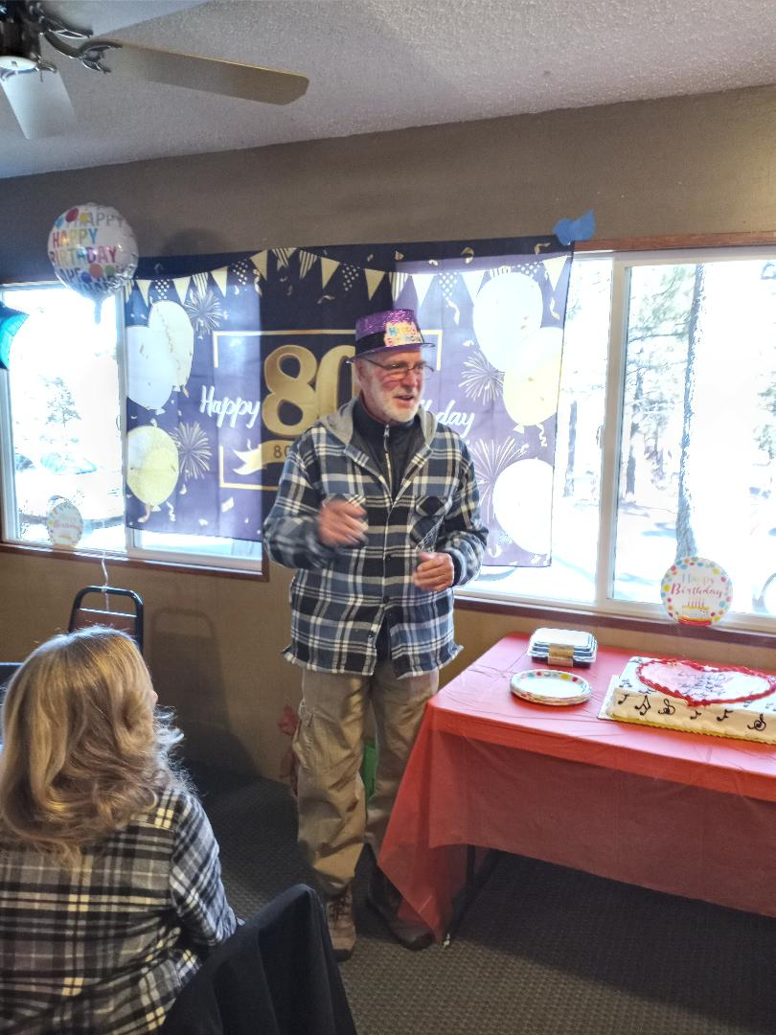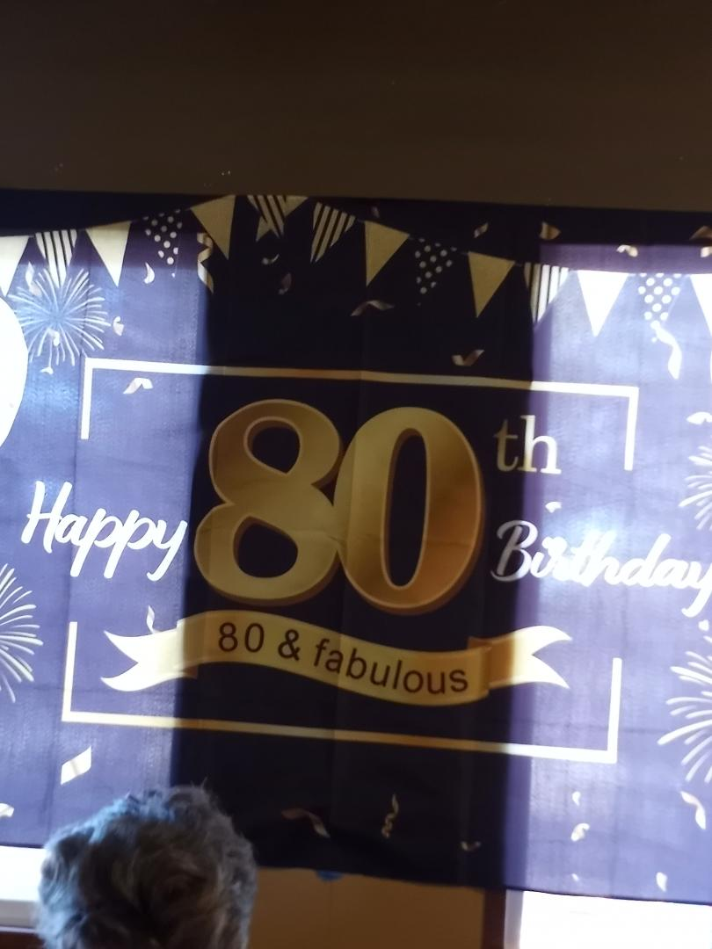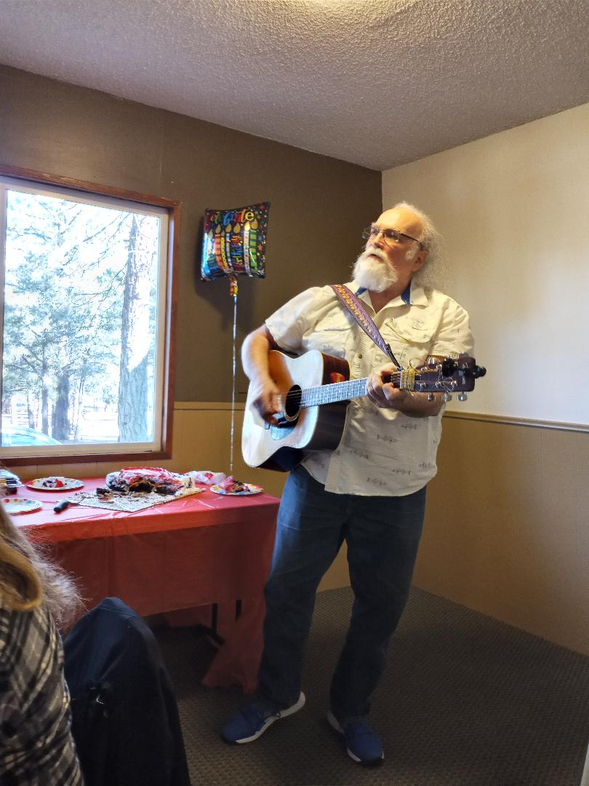

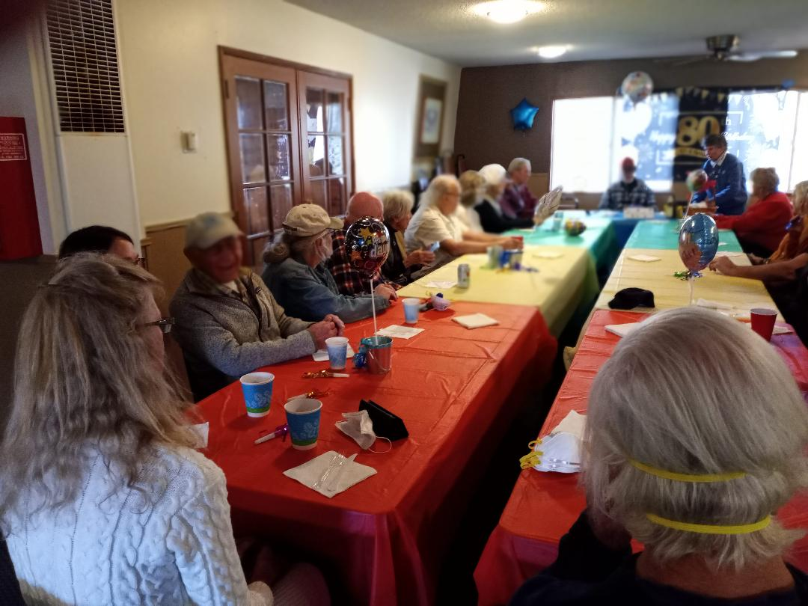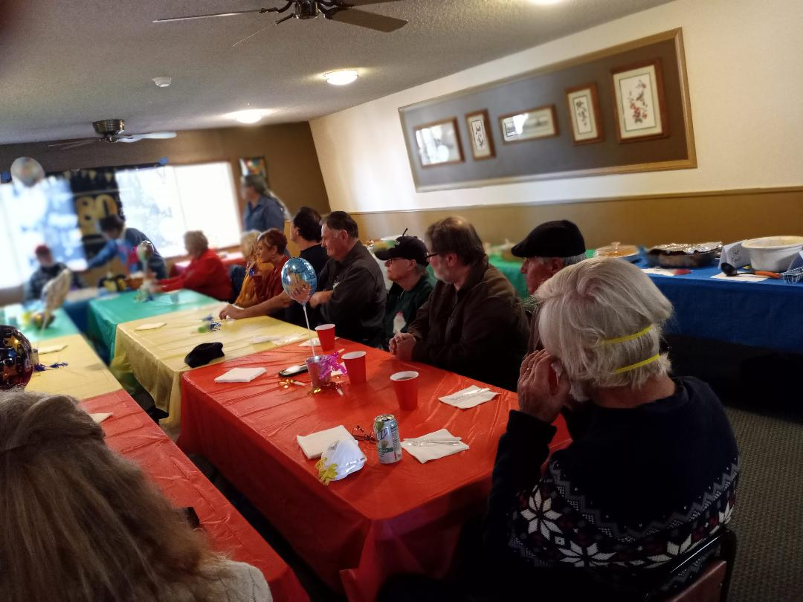

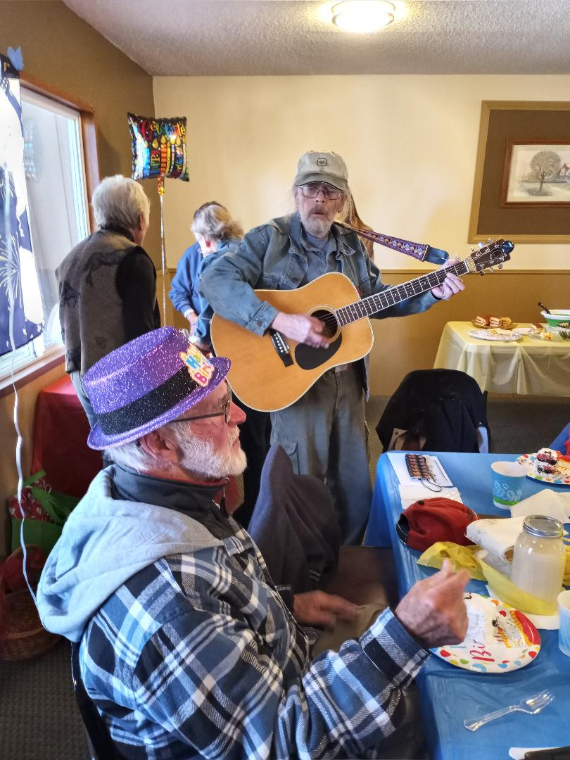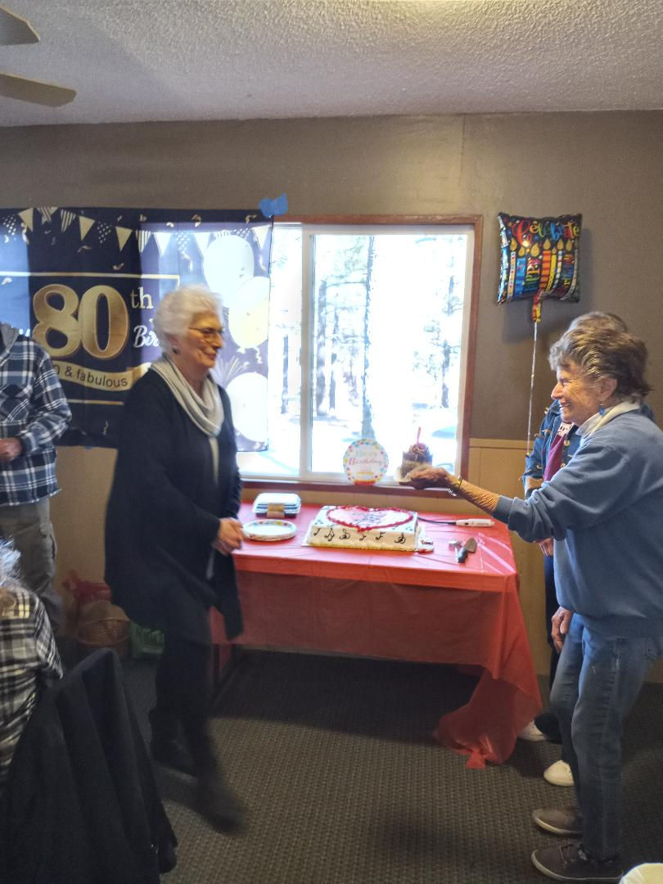
It was Liz’s birthday, too!




