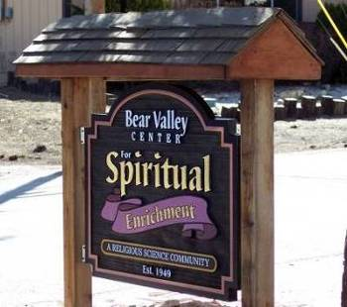


Bear Valley Center for Spiritual Enrichment

A Religious Science Community
“Open at the Top”
JUNE 2022
Newsletter

Mailing address - P. O. Box 4184, Big Bear Lake, CA 92315,

Email:bvcse2000@gmail.com Website: www.bvcse.org

501C3 tax ID #95-3685187
Our purpose is to inspire and nurture spiritual growth by accepting a loving, all-inclusive community through teaching, healing, and serving, for the highest good of all.
We are the Mind of God knowing, the Heart of God loving, and the Hands of God serving.

Newsletter staff: Editor, Ellen Kesler
Newsies – Mac & Hamish Kesler

Calendar
June 6th- - “Conscious Living Study Group”, 3:00 pm ON ZOOM - go to BVCSE Facebook for
Link*, or our website: www.bvcse.org
June 13th - “Conscious Living Study Group”, 3:00 pm ON ZOOM - - go to BVCSE Facebook for
Link*, or our website: www.bvcse.org
June 14th⁻ FLAG DAY
June 15^{th -} Board of Trustees meeting, 1:30pm ON ZOOM
June 19th – FATHER’S DAY
June 20th “Conscious Living Study Group”, 3:00 pm ON ZOOM - - go to BVCSE Facebook for
Link*, or our website: www.bvcse.org
June 21^{st –} FIRST DAY OF SUMMER
June 26^{th -} -In-person Service begins 11:45am, Bridges Presbyterian Church – Rev. Michael Curcuru, guest
speaker
June 27th - “Conscious Living Study Group”, 3:00 pm ON ZOOM - - go to BVCSE Facebook for
Link*, or our website: www.bvcse.org

ATTENDANCE…

*To attend the Conscious Living Study Group and get the Zoom link, you can go to Bear Valley Center for Spiritual Enrichment on Facebook , or www.bvcse.org

⁕⁕⁕ NOTICE OF CANCELLATION ⁕⁕⁕

Due to the same people in the Sacred Circle are the same ones in the Conscious Living Study Group, the Sacred Circle will no longer meet.

⁕⁕⁕⁕⁕⁕⁕⁕⁕⁕⁕⁕ ATTENTION EVERYONE! ⁕⁕⁕⁕⁕⁕⁕⁕⁕⁕⁕⁕
 The Board of Trustees has decided to have a once-a-month
This Photo by Unknown Author is licensed under CC BY
service at Bridges Presbyterian Church at our normal time,
11:45am, starting Sunday, June 26th, with
Rev. Michael Curcuru as our guest speaker.

Birthdays!

BIRTHDAYS

6/3 – Rhonda Smith
6/5 – Bill Hazewinkel
6/18 – Marla Henrich
6/28 – Kiki Williams

SPEAKER TOPIC for June
June 26th
Rev. Michael Curcuru
“And Still I Rise”
Jeanne Houston speaks of living “A yeasty life.”” Yeasty lives,” require we rise in courage, commitment, clarity. Courage to move beyond our old descriptions. Commitment to move in new directions. Clarity of living our now destiny of impassioned purpose. We will share stories; personal, borrowed, and biblical. Stories that move us from the old to the new, to the now of living “A yeasty life!” Will Rogers said it this way,“Never let yesterday, use up too much of today!” And so it is!

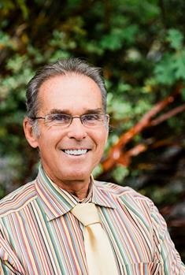

Inspirational Article

“Silence Speaks”

To be in the silence is to have gone beyond the concept of being – to actually being with Being, and becoming available to, “Not my will, but God’s will be done, in all of my thoughts and all of my actions”. Imagine this form of surrender activating the love that defines us and puts us in touch with our most powerful resource; Silence – the voice of God expressing itself as greatness; all-knowing, all-present, and all-powerful, available to us just for the asking, and patience in the silence to hear the voice of our Maker giving us alignment and assignment so that we can, in God’s own way, live, move, and have our Being in love’s intended purpose - to maintain and sustain us. Let us remind each other that in the worldly challenges going on, what is within us is greater than what is in the world and realize that everything we see was created by what we don’t see. Let’s explore the holy, wholly Spirit; the love that defines us and the Holy Spirit are one.

Namastѐ, Art Harriman
.
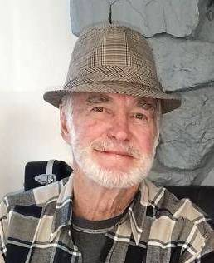

⁕⁕⁕⁕⁕⁕⁕⁕⁕⁕⁕⁕⁕⁕⁕⁕⁕⁕⁕⁕⁕⁕⁕⁕⁕⁕⁕⁕⁕⁕⁕⁕⁕⁕⁕⁕⁕⁕⁕⁕⁕⁕⁕⁕⁕⁕⁕⁕⁕⁕⁕⁕⁕⁕⁕⁕⁕⁕⁕⁕⁕⁕⁕⁕⁕⁕⁕⁕⁕⁕⁕⁕⁕⁕⁕

WHAT’S THE HAPS?

⁂ On June 16th, the Big Bear Group of the Sierra Club will have their monthly General Meeting in the
Bridges Presbyterian Church, 579 Knickerbocker, Big Bear Lake at 6:30pm. The speaker will be
Reggie Lamson, General Manager of the DWP. He will be giving us an update on the Sustainable Water
Project – the plan that has been in the works for years to get reclamation water into the Stanfield Marsh
which will add to the lake.
Everyone is welcome and it’s free!



AKASHIC PRAYER FOR COURAGE

Mother, Father, Goddess, God, as I stand on this precipice today,
I ask for courage.
There is a leap of Faith that I am being called to take.
Please hold me in your Love and let me feel the courage of the Divine.
I accept with gratitude this courage and support.
So it is. Blessed Be.

(Akashic Records are the records of your soul’s journey, from the time you first arise from Source until you eventually return home. For. For more info, go to www.AkashicKnowing.com)



ACCESS THE DIVINE PRESENCE

By Diana Ensign

Spiritual luminaries such as Ernest Holmes teach us that beauty and harmony always exist: from miraculous atoms swirling throughout the vast universe that birth new life, to the gentle swaying treetops deep in the Amazon forest that provide a protective canopy for millions of small creatures far below, to the bright glow of the sun’s rays that appear each morning over the distant horizon.
When we are quiet, still and calm, we can feel the divine blessing of being alive. This moment. This day.
What prevents us from seeing the beauty that surrounds us more often? What gets in the way of realizing our profound connection to all that is sacred and holy? How do we align our lives in partnership with the Divine when life feels chaotic and unsettling?
Holmes proclaimed, “We must open the door of our consciousness and permit It to enter. It is willingness, recognition and acceptance that give entrance to the Divine Presence. It is faith and acknowledgment that permit Its creative Power to flow through our word.”
How do we go about opening the door of our consciousness? Where do we begin on this path of greater awareness of the Divine Presence?
Often in life, we first have to acknowledge what is not working before we can proceed to the next step of being willing to try something different. When we admit we don’t have all the answers to life’s challenges, we learn to ask for help. In doing so, we release our egos, our agendas and our illusions of control. We then stand at the threshold of something astonishing; an open door to the Divine Presence, ready to receive.

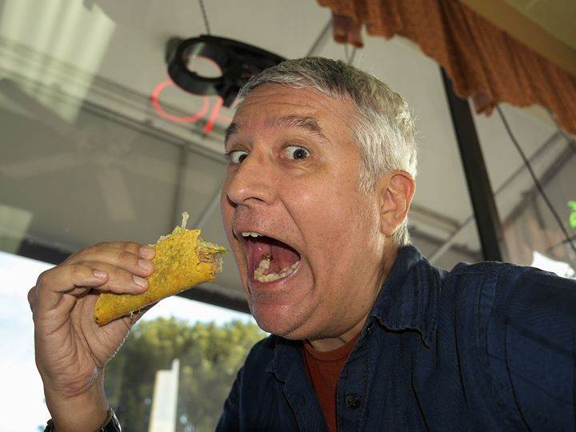

VACATION TRAILS
By LaVerne P. Larson
Vacation trails…where do they lead,
To seashore, woods and farm,
With every golden hour
Touched by some magic charm.

We plan and dream where we’ll go
At this special time,
To get our fill of fun or rest
Which makes the days sublime.

The seashore beckons some of us
With surf and mounds of sand,
We swim and boat and frolic in
This shining fairyland.

The woodlands call the campers forth
To bring their tents and gear,
That they may view the wonders
Of nature nestled here.

The quiet rustic beauty
Of the farm is calling too;
It wants to share its loveliness
From dawn to dusk with you.

Vacation trails lead everywhere
And we are free to roam,
To gather joy and memories
That will last when we come home.

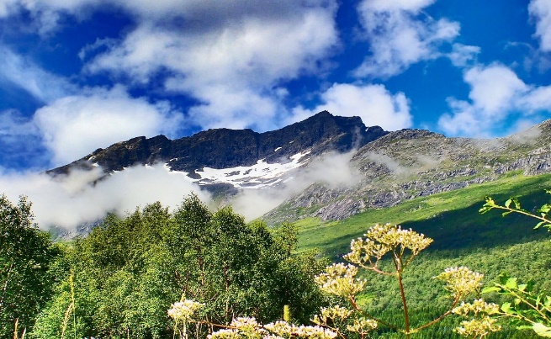
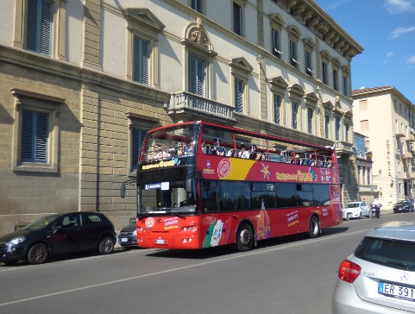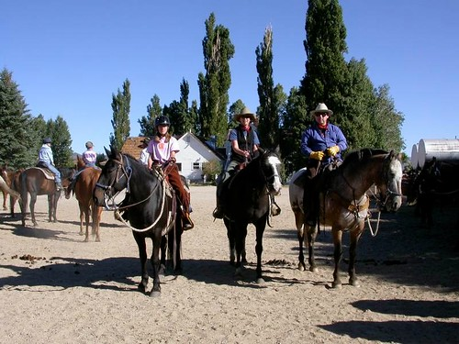
This Photo by Unknown Author is licensed under CC BY-SA-NC
This Photo by Unknown Author is licensed under CC BY



When I get a headache, I take Just once, I want the Did you hear about
two aspirin and keep away username and password restaurant on the
from children just like the prompt to say, “Close moon? Great food,
bottle says. enough.” but no atmosphere.

 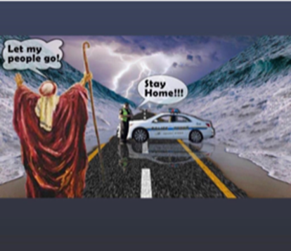 Moses and Covid
Anybody remember these days?


